DRAFT
Compute Markets & Compute Exchanges: An Institutional Primer
Financializing the Defining Commodity of the AI Era — Venues, Indices, Derivatives, and the Coming Benchmark War
Digital Assets & AI Infrastructure | July 2026
▸ What should investors do?
▸ Why now? Three forcing functions
▸ What is “compute” as a commodity? The unit-of-account problem
▸ First principles: what a GPU-hour should cost
▸ The four-layer market stack
▸ The players: who does what, and what should investors watch
▸ Data methodologies: how a compute index actually gets built
▸ How the financial products interact with compute markets
▸ The deal book: financial transactions in compute markets
▸ The cost-of-capital prize: working the arithmetic
▸ What are the risks? The honest list
▸ The scoreboard: what to track quarterly
▸ Read-throughs to coverage [FOR YOUR EDITING]
▸ Glossary (quick reference)
▸ Sources, verification status and tiering

What should investors do?
Compute is being financialized in real time. In a single week in May 2026, both CME Group (with Silicon Data) and Intercontinental Exchange (with Ornn) announced regulated GPU compute futures, pending CFTC review [T1]. Underneath them, a spot-and-benchmark layer is already live, and above them a credit layer is already moving tens of billions of dollars a year. The window between “no market exists” and “the benchmark is decided” is the window we are in right now. Our view, in order of conviction:
- The benchmark layer is the moat, not the exchange layer. Exchanges are abundant — at least five venues now compete for compute derivatives. Trusted reference prices are scarce. Whoever’s index settles the liquid contract becomes the “Brent of compute,” and index licensing is a near-100% incremental-margin annuity. Silicon Data (CME-aligned, DRW-backed) and Ornn (ICE- and Architect/AX-aligned) are the two leading candidates; Compute Desk backs Architect’s American Innovation Exchange. This is a repeat of Brent vs. WTI: the market will likely converge on one or two surviving benchmarks, with everyone else specializing regionally or by tier — or exiting.
- The cleanest listed exposure runs through the incumbent exchanges. CME and ICE entering within a week of each other (May 12 and May 19, 2026) is the institutional validation signal. If compute futures reach even a fraction of the scale of power or natural-gas complexes, the listed-exchange P&L accrues to CME and ICE, not to the start-ups — the start-ups’ upside is being acquired for their index intellectual property or their physical-delivery networks.
- The near-term prize is cheaper capital, not futures volume. A liquid forward curve lets lenders underwrite GPU-backed debt against a hedgeable reference rate, compresses the cost of capital for funded operators, and — critically — exposes unfunded order books to mark-to-market discipline. Financialization is already live in credit: CoreWeave alone has closed roughly $24Bn of cumulative GPU/HPC-backed loan facilities since 2023, including the first investment-grade-rated deal [T1]. A visible, falling forward curve is a risk to miners and neoclouds trading at AI-datacenter multiples on unhedged, unfunded capacity claims.
- The investment case does not depend on any single venue winning — and it is materializing faster than volumes. Even a thinly traded curve changes behavior: it becomes the discount rate for GPU collateral, the settlement reference for OTC swaps and parametric insurance, and the public scoreboard for the AI-capex debate. Benchmarks monetize before liquidity arrives. Best to be exposed across layers — index owners, exchanges, funded operators, and the credit complex — rather than concentrated on one contract succeeding.
The leap of faith, flagged honestly: every prior attempt to financialize compute — most famously Enron’s bandwidth-trading business in 1999–2001 — failed on standardization and counterparty trust. The bull case requires that (i) GPU heterogeneity is tameable by index methodology, and (ii) two-sided hedging demand persists. We think both hold this cycle — the evidence is the body of this note — but these are the two load-bearing assumptions, and section 11 prices them.

Why now? Three forcing functions
First, the price signal finally exists. Every commodity market begins with a published price, and until May 2025 compute did not have one. Silicon Data launched SDH100RT, the first daily GPU rental benchmark, on Bloomberg in May 2025, computed from roughly 3.5 million pricing data points across 30+ sources [T3, methodology self-described; launch covered by IEEE Spectrum and Bloomberg, T2]. Ornn’s OCPI followed, built only from printed transactions and distributed on Bloomberg from April 2026 [T1/T3]. Compute Desk publishes indexes on H100, H200, B200 and B300 rentals that will settle Architect’s exchange [T1]. You cannot settle a derivative without a reference rate; as of 2025–26, reference rates exist, publish daily, and have a one-to-two-year track record.
Second, volatility returned — and rotated to new silicon. The 2024–25 H100 glut (the index fell 23% from its $3.06 September 2024 peak to $2.36 by June 2025 [T3]) flipped into a 2026 crunch: one-year contract rates rose ~38% in five months ($1.70 to $2.35, October 2025 to March 2026, per SemiAnalysis [T3]), on-demand capacity effectively sold out, and the B200 rental index rose 24% in a single month (March 2026) while H100 hyperscaler tiers sat flat [T3]. Volatility is the raw material of a derivatives market: flat prices attract neither hedgers nor speculators. Exhibits 1, 3 and 5 show the record.
Third, the capex is too large to leave unhedged. Hyperscaler AI datacenter spend now runs to hundreds of billions annually, financed increasingly with debt. The four largest hyperscalers are guiding to roughly $725Bn of combined 2026 capex, up ~77% from ~$410Bn in 2025 [T2: Goldman Sachs estimates via press; company guidance]; Morgan Stanley projects $250–300Bn of hyperscaler debt issuance in 2026 alone, and JPMorgan sees $30–40Bn a year of data-center securitization in 2026–27 [T2: Bloomberg]. Lenders demand a hedgeable reference rate. Don Wilson (DRW) has publicly framed compute as a candidate for “the largest commodity in the world” [T1: CME release], and BlackRock’s Larry Fink has publicly floated compute futures [T2]. Washington has, unusually, pre-blessed the concept: the administration’s AI Action Plan recommends development of spot and forward markets for GPU compute. Commodities usually fight regulators on the way up; this one has political cover from day one.
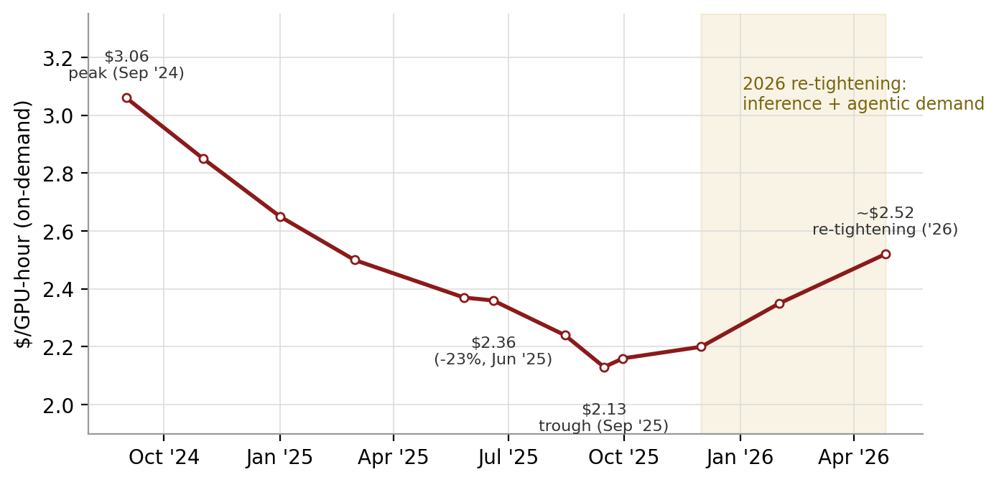
Exhibit 1: Silicon Data H100 Neocloud rental index (SDH100RT): $3.06 peak (Sep ’24) → 23% correction → 2026 re-tightening. Boom → glut → re-tightening: the volatility that makes a derivatives market viable.
Source: recreated from Silicon Data published prints (index launch release May 2025; “A Correction in Compute” blog, Jun 2025; Sep 2025 market update; 2026 blog series). The official daily series sits on Bloomberg (ticker SDH100RT) — replace this recreation with a terminal pull before client distribution. Tier: T3 (self-reported index data), anchor points verifiable at silicondata.com/blog. Intermediate months are interpolated —GDA -style illustration, not published prints.
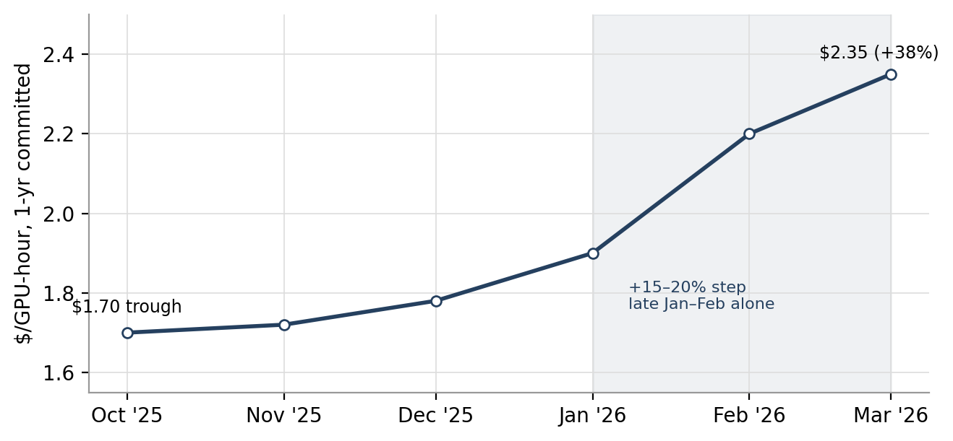
Exhibit 5 (shown early for the demand story): 1-yr H100 contract rates +38% in six months (SemiAnalysis $1.70 → $2.35): the embryonic term structure. A committed-term price rising while spot tiers stayed soft is the signature of production inference demand replacing exploratory training demand.
Source: SemiAnalysis H100 1-Year Rental Price Index, built from monthly surveys of 100+ market participants (newsletter.semianalysis.com, “The Great GPU Shortage,” Apr 2026; free dashboard at gpu-index.semianalysis.com; corroborated by Seeking Alpha, Apr 2, 2026). Tier: T3 research-house survey; monthly shape between the two published endpoints is stylized from SemiAnalysis’s own “+15–20% step late Jan–Feb” commentary.

What is “compute” as a commodity? The unit-of-account problem
Every commodity market begins by answering: what exactly is one unit? Oil solved it with grades (WTI: light sweet crude, sulfur <0.42%, delivered Cushing). Compute’s answer is emerging as:
One GPU-hour of a specified accelerator (e.g., NVIDIA H100 SXM 80GB), specified tier (neocloud vs. hyperscaler), specified lease type (on-demand vs. committed term), normalized for region and configuration.
This matters because compute is heterogeneous in ways oil is not. The same H100 chip trades at roughly $2.35–2.52/hr on neocloud one-year-committed and on-demand benchmark terms, and around $7.48/hr on hyperscaler enterprise-SLA on-demand tiers — a ~3x spread on identical silicon (Exhibit 2). Across the whole on-demand market the dispersion is wider still: one public tracker of 47 providers shows listed H100 rates from $0.34 to $14.90/hr around a $3.45 mean [T3: getdeploying.com, Jul 2026]. The spread is not an inefficiency to be arbitraged away — it reflects real differences in SLA, interconnect, networking, support, and counterparty quality. Index methodology (section 7) exists precisely to tame this heterogeneity into a tradeable number.
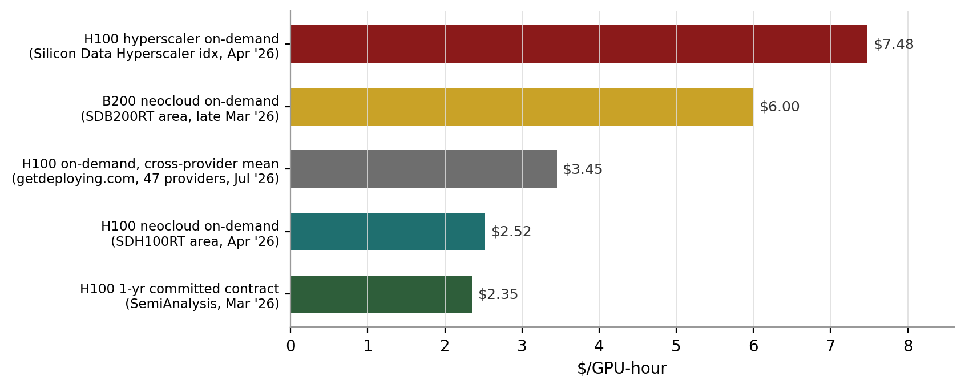
Exhibit 2: One chip, ~3x price spread — why “the GPU price” does not exist. $/GPU-hr across contract tenor and provider tier, Q1–Q2 2026.
Sources, by bar: Silicon Data H100 Hyperscaler index blog (Apr 2026, ~$7.41–7.52) [T3]; Silicon Data B200 commentary (spiked above $6.00/hr late Mar 2026) [T3]; getdeploying.com cross-provider tracker mean, Jul 2026 [T3]; SDH100RT area per Polymarket resolution data and Silicon Data blogs, Apr 2026 [T3]; SemiAnalysis 1-yr contract index, Mar 2026 [T3]. All are self-reported or research-house series — verify on terminal before client use. GDA-style illustration.
The first-principles commodity test — scored honestly
A good is a tradeable commodity when units are fungible after standardization, quality is measurable, there is continuous two-sided flow, and price is volatile enough to need hedging. Score compute against the classics:
Fungibility — partial, solvable. An H100-hour in Ohio and an H100-hour in Texas are near-substitutes for most training and batch inference once normalized for interconnect and SLA. This is electricity’s problem (location, non-storability), not oil’s (grades, storage) — and electricity got PJM and Nord Pool anyway. Cash settlement plus EFP mechanisms (section 8) sidestep the delivery problem the way index-settled power contracts do.
Non-storability — a feature for derivatives, not a bug. An unused GPU-hour vanishes; you cannot warehouse it. Consequence: the forward curve reflects expected scarcity, not cost-of-carry — exactly like electricity, and unlike gold. Non-storable commodities need forwards more, because inventory cannot buffer price risk.
Two-sided hedging demand — present, the decisive test. Natural shorts: neoclouds and miners-turned-neoclouds sitting on depreciating, debt-financed fleets. Natural longs: AI labs and enterprises with token-denominated revenue and GPU-denominated costs. The failed futures (uranium, onions, steel in early attempts) mostly died for lack of one side; compute demonstrably has both.
Depreciation — the genuinely new problem. Unlike oil, the underlying asset improves ~2x in price-performance every product cycle, so any benchmark chases a depreciating asset. This is why indices are per-SKU (H100, H200, B200, B300 separately) rather than “compute” in the abstract, and why new-silicon contracts will carry the volatility and hedging demand while old-silicon contracts fade — Exhibit 3 already shows this rotation.
Verdict: compute is electricity, not oil — a non-storable, locationally-flavored, index-settled commodity. The precedents that matter are PJM power, JKM LNG, and IRU bandwidth capacity, not Brent barrels.

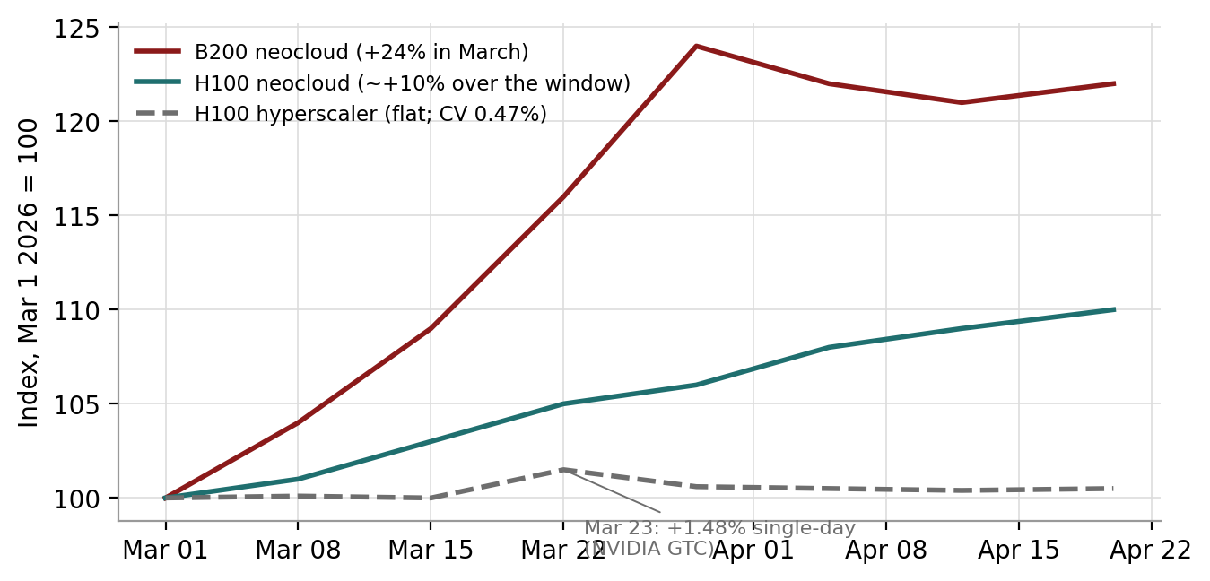
Exhibit 3: B200 +24% in March ’26 vs. flat H100 tiers: new silicon carries the volatility and the hedging demand. Indexed to Mar 1, 2026 = 100.
Source: recreated from Silicon Data blog series (“B200 GPU rental index surged 24% in March 2026 while H100 barely moved”; H100 Hyperscaler index Mar 1–Apr 20 coefficient of variation 0.47%, +1.48% single-day move Mar 23; H100 neocloud tier “rose double digits” over the spring window), silicondata.com/blog [T3]. Weekly path within the window is interpolated — illustration, not published prints.
Terminology box — the physical market
Spot price: what one GPU-hour costs for immediate delivery, i.e., on-demand rental rates posted or transacted today.
On-demand vs. reserved/committed: on-demand is pay-as-you-go hourly; reserved is a committed term (typically 1–4 years) historically at a large discount to on-demand — though in the 2026 crunch, term has been rising while spot tiers stayed mixed. Reserved capacity is economically a forward contract in physical form; this is the key insight: the compute market already trades forwards, it just calls them “contracts.”
Neocloud: GPU-specialist cloud providers (CoreWeave, Nebius, Crusoe, IREN’s cloud arm, etc.) as distinct from hyperscalers (AWS, Azure, GCP). Neocloud pricing is competitive and volatile; hyperscaler on-demand pricing is a posted enterprise ceiling and barely moves (Exhibit 3).
Offtake agreement: a multi-year bilateral commitment to buy capacity — today’s dominant risk tool, and an imperfect one: buyers accept longer commitments than they want, sellers give up flexible-term margin, and lenders will only finance against a large creditworthy counterparty.

First principles: what a GPU-hour should cost
Before trusting anyone’s index, it is worth building the price from the ground up. A GPU-hour has four cost components: the hardware, the electricity, the building around it, and the money that paid for all three. Every input below is public or flagged as our estimate.
Hardware amortization. An H100 SXM module trades around $25,000–$40,000; loaded server share per GPU (chassis, networking, storage) puts invested capital at roughly $28,000–$35,000 per GPU [T3: vendor and reseller trackers; our midpoint $28k is an estimate]. Amortized over a 4-year accounting life at 85% utilization: $28,000 ÷ (4 × 8,760 × 0.85) ≈ $0.94/hr. Note the two most contested assumptions in all of AI finance sit inside this single line: useful life (3, 4, 5 or 6 years?) and utilization.
Power. An H100 has a TDP of 700W — a power-planning rate, not a measured draw, but the right number for capacity costing. Multiply by a PUE of ~1.3 for cooling and facility overhead and by the 2025 US average industrial electricity price of 8.6¢/kWh [T1: EIA]: 0.70 kW × 1.3 × $0.086 ≈ $0.08/hr. The striking result: at grid parity, electricity is under 5% of the H100 cost stack. Power matters as a constraint on how many GPUs can be energized (the interconnection queue problem), far more than as an operating cost per hour — though behind-the-meter operators do capture a real, if second-order, cost edge.
Datacenter and operations overhead. Colocation or facility charge, networking amortization beyond the server, remote hands, and staff. We estimate $0.35/hr — flagged as an estimate; ranges of $0.20–0.50 appear in public TCO teardowns [T3/T4].
Cost of capital. The invested ~$33k per deployed GPU (hardware plus its share of facility) must earn a return. At a 12% blended pre-tax cost of capital — roughly where speculative-grade neocloud debt plus equity blends — that is ~$0.45/hr at 85% utilization. This is the line the whole thesis operates on: it is the only component a forward curve can directly shrink.
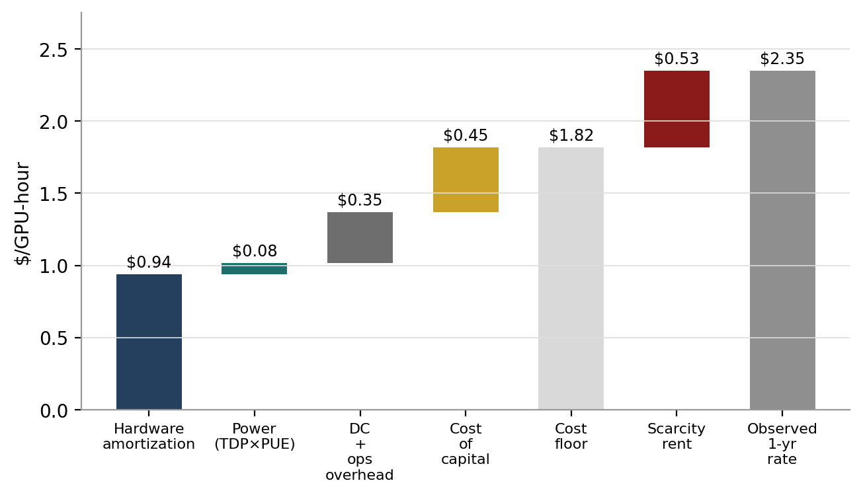
Exhibit 9: the bottom-up H100 GPU-hour cost stack vs. the observed 1-yr contract rate. Floor ≈ $1.82; observed $2.35; the ~$0.53 gap (~29% above floor) is scarcity rent.
Sources: hardware pricing per public reseller/cloud trackers [T3]; TDP 700W per NVIDIA datasheet [T1]; electricity 8.6¢/kWh 2025 US industrial average per EIA [T1]; PUE 1.3, overhead $0.35, 4-yr life, 85% utilization, 12% capital charge are GDA-draft estimates [flagged]; observed rate = SemiAnalysis 1-yr contract index, Mar 2026 [T3]. Each input deserves a sensitivity range in the accompanying Excel model — the floor moves ~$0.23/hr for each year of useful life added or removed.
What the gap tells you. When the market rate sits ~29% above a full-cost floor, sellers are earning scarcity rent — the market is rationing capacity by price, which is precisely the condition under which buyers want to lock forward prices and sellers can profitably write calls. When the observed rate falls below the floor (as it arguably did for H100s in late 2025 at $1.70, if one assumes shorter useful lives), operators are burning capital, and it is lenders — not renters — who carry the pain. The cost stack is therefore also the credit model: every GPU-backed loan in section 9 is implicitly a bet on where the rental rate sits relative to this floor for the life of the loan.
A demand sanity check from physics. Is the 2026 re-tightening plausible from first principles? Inference on a transformer costs roughly 2N floating-point operations per token, where N is parameter count (training costs ~6N per token seen). A 70B-parameter model therefore needs ~1.4×10¹¹ FLOPs per token. An H100 delivers ~10¹⁵ FLOP/s of dense BF16 throughput on paper; at a realistic 40% model-FLOPs-utilization that is 4×10¹⁴ effective — call it ~2,900 tokens per second, or ~10.4M tokens per GPU-hour. At the $2.35 contract rate, raw compute cost is ~$0.23 per million tokens for a 70B-class dense model — comfortably below prevailing API prices, which is why serving frontier-adjacent models remains profitable and why every incremental agentic workflow (thousands of tokens per task, not hundreds) pulls GPU demand up with it. Frontier training compute has been growing 4–5x per year for over a decade [T1: Epoch AI, free dataset at epoch.ai/data]. The demand side of the volatility is structural, not sentiment.
Plain-language recap: a GPU-hour is mostly the machine and the money, barely the electricity. The market price above the all-in cost is rent for scarcity; the market price below it is a slow-motion loss for whoever financed the machine. Futures exist to let both sides stop guessing which regime comes next.

The four-layer market stack
We find it cleanest to think of compute capital markets as four stacked layers. Liquidity is built bottom-up; risk transfer and financing sit on top. Each layer is being built by different players, and value will accrue unevenly.
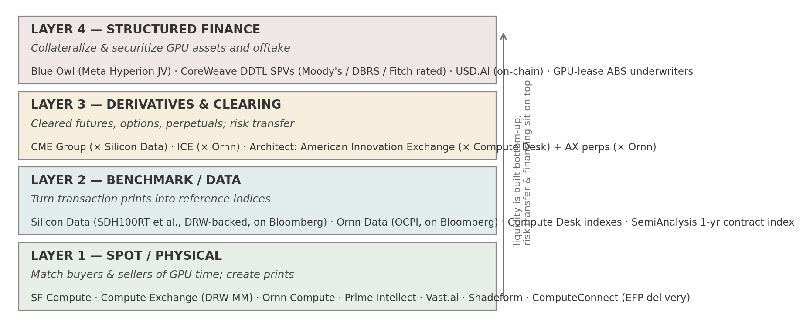
Exhibit 6: the venue stack — Silicon Data/CME, Ornn/ICE, Architect, Compute Desk, SF Compute, USD.AI and peers mapped across the four layers.
Source: company announcements and press releases (all cited in section 15), GDA mapping. Tier: T1 for the partnerships shown; layer placement is our judgment.
Layer 1 — spot / physical. Marketplaces match buyers and sellers of GPU time and, crucially, produce transaction prints. SF Compute runs an order book where compute trades by the hour and contracted-but-unused capacity is sublet ($40Mn Series A, Nov 2025, ~$300Mn valuation, DCVC/Wing [T2: WSJ, DCD]). Compute Exchange runs auctions with DRW as market maker. Ornn Compute aggregates dedicated capacity across neoclouds with a secondary market for transfers. Spot venues compete on liquidity and are the most commoditizable layer.
Layer 2 — benchmark / data. Data firms turn prints into standardized reference indices: Silicon Data (SDH100RT and family, Bloomberg-distributed, DRW- and Jump-backed), Ornn Data (OCPI, transaction-only, Bloomberg-distributed), Compute Desk (per-SKU rental indexes settling Architect’s exchange), and SemiAnalysis (survey-based 1-yr contract index). This layer is winner-take-most: a market converges on one accepted price, and the accepted index becomes a licensing annuity attached to every cleared contract.
Layer 3 — derivatives / clearing. Exchanges list cleared futures and options on the layer-2 benchmarks: CME (× Silicon Data), ICE (× Ornn), and Architect — which is running the full playbook: offshore perpetual futures on GPU and DRAM prices via its Bermuda exchange AX since January 2026, a US designated contract market (the American Innovation Exchange) acquired via IMX Health in May 2026, and options and calendar-spread products, all pending regulatory review [T1]. This layer monetizes clearing fees and distribution, and is where the clearest listed-equity exposure sits.
Layer 4 — structured finance. The cash flows get collateralized and securitized: GPU-backed delayed-draw term loans (CoreWeave’s five facilities), the Meta/Blue Owl Hyperion JV, data-center ABS/CMBS, and on-chain GPU credit (USD.AI). This is the layer where real money already moves — section 9.
The strategic insight: the benchmark is the chokepoint — and DRW sits at the center
Spot venues can be commoditized. Exchanges compete on distribution and clearing trust. But the reference index is winner-take-most, because a derivatives market needs everyone settling against the same number — that is what happened with Brent, Henry Hub, and JKM.
This is why DRW, a 30-year Chicago trading house that has seeded multiple exchanges, is positioned behind both Silicon Data (the CME-aligned benchmark) and Compute Exchange (a spot venue): control the index and the prints that feed it, and you sit at the center of the entire stack regardless of which exchange wins.
The “benchmark war” to watch: CME/Silicon Data vs. ICE/Ornn vs. Architect/Compute Desk. History (Brent vs. WTI) says two can survive by specializing; three or more fragment liquidity and delay the whole stack.

The players: who does what, and what should investors watch
The participant set maps onto the natural longs and shorts of any commodity market, plus intermediaries.
Natural shorts (sellers, hedging falling prices): neoclouds and GPU-as-a-service operators — CoreWeave, Nebius, and the crypto-miner-to-AI cohort (IREN, CIFR, WULF, CORZ and peers) — sitting on depreciating, debt-financed fleets they must keep utilized; hyperscalers with surplus capacity, who are the largest potential sellers but benefit from opacity and may resist participating.
Natural longs (buyers, hedging rising prices): AI labs and model developers exposed to availability risk and price spikes; enterprises whose unit economics are token-denominated; second-tier clouds that resell capacity and need predictable input costs. The 2026 crunch — 36–52-week lead times on H200/B200, on-demand sold out, contract renewals at original prices through 2028 [T3: SemiAnalysis] — is precisely the environment that turns reluctant buyers into forward hedgers.
Intermediaries: benchmark providers (layer 2 above); exchanges and clearing houses (CME, ICE, Architect’s DCM); market-makers and prop firms (DRW most visibly; Jump backs Silicon Data; Wintermute has reportedly executed an OTC compute forward referencing H100 pricing [T4: reported via social/Bloomberg screenshot in our reading pack — verify against a Bloomberg print before citing to clients]); and the financiers — Blue Owl, Blackstone Credit, Magnetar, Morgan Stanley/MUFG as arrangers, Moody’s/DBRS/Fitch as raters, and stablecoin-funded on-chain lenders (USD.AI/Permian Labs).

Venue-by-venue scorecard
Venue / firm | Model & layer | Status and key facts [tier] | What to watch
CME × Silicon Data | Regulated futures on SDH100RT-family indices (L3 on L2) | Announced May 12, 2026; pending CFTC review; launch targeted “later this year” [T1]. Silicon Data: DRW-backed; H100/A100/B200 + Hyperscaler indices + no-arbitrage forward curve, on Bloomberg [T3]. | Contract spec (which tier settles?); first open-interest prints; index licensing terms
ICE × Ornn | Regulated futures on OCPI (L3 on L2) | Announced May 19, 2026; USD cash-settled; H100/H200/B200/RTX 5090 series; pending approval [T1]. Ornn: $33Mn seed led by a16z crypto announced Jun 24, 2026 [T2: Bloomberg]; OCPI transaction-only, on Bloomberg since Apr 2026; Ornn Compute physical layer + secondary market. | OCPI print volumes; whether transaction-only methodology wins institutional trust vs. broader-input rivals
Architect Financial Technologies | Full-stack exchange group (L1 delivery + L3) | Jan 21, 2026: AX (Bermuda) perpetual futures on GPU + DRAM w/ Ornn data [T1]. May 28, 2026: acquired IMX Health LLC (a US DCM) to launch the American Innovation Exchange — futures/options on compute + AI supply-chain commodities, Compute Desk indexes, pending review [T1]. Jul 8, 2026: ComputeConnect EFP network w/ Compute Desk linking futures to physical GPU delivery [T1]. Pillar partnership for automated corporate hedging [T1]. | CFTC signoff on the DCM; whether EFP delivery solves the physical-settlement gap; ETF flow routed to its venues
SF Compute | Spot order book, resale/sublease (L1) | $40Mn Series A Nov 2025 at ~$300Mn post (DCVC, Wing; ~$52Mn total; ~10% take rate; >$100Mn hardware on platform) [T2/T3]. Management explicit that cash-settled futures are the long-term goal; a spot market today. | Volume disclosure; whether its prints feed any settlement-grade index
Compute Exchange / Compute Desk | Auction spot venue + indexes + Compute Clear delivery platform (L1+L2) | DRW as market maker; standardized contracts; Compute Desk indexes settle Architect’s AI Exchange and power ComputeConnect basis tables [T1/T3]. | Whether owning spot + index + delivery simultaneously creates the vertical moat it is aiming for
Prime Intellect / Vast.ai / Shadeform | Aggregators (L1) | Prime Intellect: 50+ providers aggregated, verifiable-inference layer, $20Mn+ raised [T2/T3]. Vast/Shadeform: price-comparison and brokerage models. | Aggregator prints as index inputs; consolidation
USD.AI (Permian Labs) | On-chain GPU-backed credit (L4) | >$1.2Bn in approved guidance/non-recourse facilities incl. up to $500Mn for Sharon AI (Jan 22, 2026; $65Mn initial draw) [T1: Business Wire; T2: CoinDesk, The Block]. Tokenized GPU collateral, stablecoin liquidity. | Loss experience through a downturn; whether tokenized collateral wins a cost-of-capital edge

Also filed but not yet analyzed in depth here: Pluto/PMEX CFTC materials referenced in industry sources [T4 — we have not independently verified these filings; treat as unconfirmed until the CFTC docket is checked].

Data methodologies: how a compute index actually gets built
The benchmark war will be decided on methodology, so it pays to understand the machinery. Building a settlement-grade compute index requires solving four problems that a simple price average cannot.
Problem 1: inputs — listed prices vs. printed transactions. Posted list prices are abundant but gameable and often stale; executed transactions are scarce but real. Silicon Data ingests ~3.5 million pricing data points daily across 30+ sources and applies statistical outlier removal [T3]; Ornn’s OCPI takes the opposite purist position — built only from printed (cleared or settled) transactions, which is its core marketing claim and the basis of the “settlement-grade” label [T1/T3]; Compute Desk references “real, privately settled transactions” [T1]; SemiAnalysis surveys 100+ market participants monthly for committed-term rates [T3]. The trade-off is coverage vs. integrity: broad-input indices risk reflecting marketing rates; transaction-only indices risk thin samples that one large deal can move.
Problem 2: normalization. The same SKU trades across subtypes (SXM vs. PCIe), geographies, cluster sizes, interconnects, and SLA tiers. A robust index normalizes to a reference configuration so that the daily number moves because the market moved, not because the sample mix shifted. This is also why providers publish families of indices — per-SKU (H100, A100, B200, B300), per-tier (Neocloud vs. Hyperscaler), and per-tenor (on-demand vs. 1-yr committed) — rather than one “compute price.” Exhibit 2 is the argument in one picture: without tiering, the index would swing 3x on mix alone.
Problem 3: manipulation resistance. A settlement index is a target the moment money settles against it. Defenses: minimum print counts, robust statistics (medians/trimmed means), independent calculation agents, and certification — Architect states its AI Exchange contracts will settle on IOSCO- and EU BMR-certified indexes [T1]. Watch for each provider’s published methodology documents; an index without a public methodology cannot anchor institutional flow.
Problem 4: the forward curve. Because compute cannot be stored, there is no cost-of-carry to pin forwards to spot; the curve must be derived from term-market observations. Silicon Data publishes a daily no-arbitrage forward curve for H100, B200 and A100 built on its indices, explicitly marketed as a settlement reference for futures, swaps and parametric insurance [T3: silicondata.com/products/forward-curve]; Ornn publishes forward curves for H100, H200 and B200 built on OCPI at data.ornn.com [T3]. The curve shape is the single most information-dense object in this market: backwardation says the market expects the supply wave and depreciation to win; contango (or a flattening out of backwardation, as Silicon Data documented between late 2025 and mid-2026) says expected scarcity is rising.
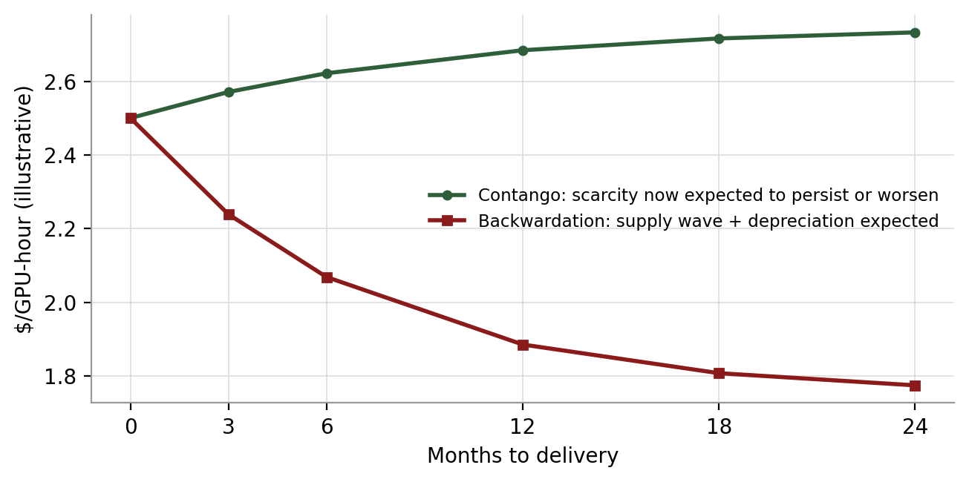
Exhibit 4: illustrative forward-curve regimes — contango (scarcity) vs. backwardation (supply wave + depreciation). Because GPU-hours cannot be stored, curve shape is pure expectation, not carry.
Source: GDA illustration (concept chart, no market data). For live curves see Silicon Data Forward Curve (Bloomberg/API) and data.ornn.com — both T3 self-published; label any pre-launch exchange screenshots (e.g., venue websites) as demo data, not market data.

How the financial products interact with compute markets
Five instrument families are arriving roughly in order of complexity. Each solves a different problem, and they interlock.
Cash-settled futures are the anchor product. A buyer (an AI lab budgeting a training run) locks the effective price of future GPU-hours; a seller (a neocloud with racks of depreciating inventory) converts uncertain rental income into a known number. No hardware changes hands — contracts settle in dollars against the reference index, exactly like index-settled power. CME/Silicon Data and ICE/Ornn contracts are pending regulatory review, targeted for late 2026 [T1]; Architect’s AX already lists perpetual-style compute futures offshore [T1].
Options turn volatility into income and insurance. A neocloud long physical inventory can write covered calls above the market and harvest premium on a depreciating asset — upside capped at the strike, cash today. A compute buyer can write cash-secured puts at the price it would happily pay anyway, collecting premium either way. Buying calls is straight insurance against a 2026-style squeeze. These are the standard hallmarks of a mature US commodity complex, and the strategies map onto compute’s natural hedgers without modification.
Exchange-for-physical (EFP) solves the delivery problem cash settlement leaves open. Compute is too heterogeneous for a clearing house to define one deliverable grade, so ComputeConnect (Architect × Compute Desk, announced Jul 8, 2026) instead lets counterparties swap a futures position for actual GPU capacity bilaterally — negotiating SKU, location, timing and a basis to the futures settlement — with standard basis tables published for different SKUs, memory configurations and locations, the futures leg booked to the American Innovation Exchange, and delivery guaranteed via Compute Desk’s Compute Clear platform [T1]. This is the same architecture energy markets use where physical delivery is messy; it is the bridge between the paper market and the racks.
Forwards and swaps (OTC) already exist bilaterally: every multi-year reserved-capacity contract is economically a physical forward, and the first financial forwards referencing H100 pricing have reportedly been executed by trading firms [T4 — verify]. A cleared futures curve makes the OTC market cheaper too, because dealers can hedge their books on-exchange.
ETFs are the retail and institutional wrapper. Six issuers have filed preliminary prospectuses for compute-futures ETFs — among the first ETFs ever filed before the underlying futures trade [T3: Architect CEO statement; individually verifiable at T1: Roundhill Compute ETF (ticker GPUX) and ProShares AI Computing Power ETF filings reported by Bloomberg, May 2026; REX AI Compute Power ETF suite incl. 2x and -1x, SEC Form 485APOS, May 21, 2026]. Futures ETFs are commodity pools using cash creation/redemption; prospectuses deliberately do not name trading venues, preserving flexibility across CME, ICE and Architect as liquidity develops. Design variants filed or floated: front-month single-SKU trackers, multi-SKU baskets, curve-weighted baskets, and AI-themed combinations with power futures and GPU-linked equities. The read-through: ETF demand can bootstrap futures liquidity — a speculative flow that solves the chicken-and-egg problem hedgers alone cannot.
How the paper stack feeds the credit stack: a lender holding GPU collateral can mark residual value to a public forward curve instead of an internal model; a developer can hedge the offtake that backs its ABS; an insurer can write parametric cover settling on the index. Every instrument above ultimately monetizes as cheaper capital in section 9 — which is why we say benchmarks monetize before liquidity.

The deal book: financial transactions in compute markets
This is the part that already touches real money. Long before futures volumes matter, compute is being financialized through credit — roughly $90Bn of landmark GPU credit, offtake and JV transactions have printed since August 2023 across the deals below, and a transparent forward curve is the missing input that makes all of it cheaper to underwrite.
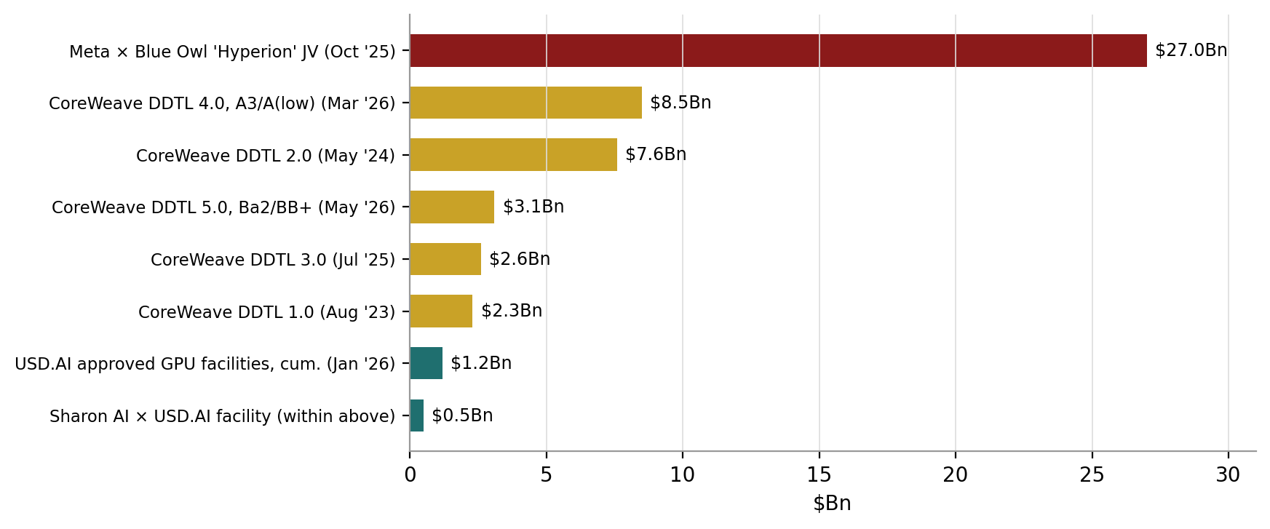
Exhibit 7: the institutional deal book — landmark GPU credit, JV and on-chain facilities, Aug ’23–May ’26.
Sources: Meta press release and 10-Q (Oct 21, 2025) [T1]; CoreWeave investor releases and SEC exhibits (DDTL 4.0 Mar 31, 2026; DDTL 5.0 May 18, 2026) [T1]; earlier facilities per Reuters and company disclosure [T2]; USD.AI/Sharon AI Business Wire release (Jan 22, 2026) [T1]. Bar lengths are facility/deal sizes, not amounts drawn.

The CoreWeave laboratory: cost-of-capital compression in real time
CoreWeave’s five delayed-draw term loans are the cleanest natural experiment in GPU-backed credit, because the same issuer, template and collateral class reprice as the market matures:
Facility | Size / date | Pricing | Rating | Notes [tier]
DDTL 1.0 | $2.3Bn, Aug 2023 | ~15% area floating | unrated | First H100-collateralized facility; Magnetar/Blackstone [T2: Reuters]
DDTL 2.0 | $7.6Bn, May 2024 | ~11% avg, contract-linked | unrated | Draws tied to customer-contract quality [T2]
DDTL 3.0 | $2.6Bn, Jul 2025 | benchmark + ~4% | unrated | Strategic-customer infrastructure [T2]
DDTL 4.0 | $8.5Bn, Mar 31, 2026 | SOFR + 2.25% / ~5.9% fixed | A3 / A(low) | First investment-grade HPC-backed financing; non-recourse SPV; anchored by Blackstone; backed by a Meta take-or-pay contract [T1: company release + SEC exhibit]
DDTL 5.0 | $3.1Bn, May 18, 2026 | SOFR + 4.50% | Ba2 / BB+ | First publicly syndicated HPC-backed facility — enables secondary trading; two non-IG customers [T1]

Three years took the same borrower from ~15% equipment-finance pricing to A-rated institutional infrastructure debt at SOFR+225 — one of the fastest cost-of-capital compressions on record, driven by lenders reclassifying the asset, not by negotiation. Two flags for precision: first, the widely circulated figure of “~$14.2Bn of CoreWeave GPU-backed debt” conflates numbers — $14.2Bn is the reported value of the Meta contract backing DDTL 4.0 [T2: Bloomberg via Quartz]; cumulative DDTL facility capacity is ~$24Bn and total company debt exceeded $21Bn as of early 2026 [T2/T1]. Second, DDTL 4.0’s investment-grade rating is borrowed from the counterparty: DBRS notes the structure’s cash flows rest on the Meta take-or-pay with no volume risk — the credit is only as strong as the offtaker’s willingness to keep paying.
DDTL 5.0 matters for a subtler reason: public syndication introduces secondary-market price discovery to GPU credit — observable spreads, basis relationships, and eventually the liquidity infrastructure an index or derivative needs to reference. Notably, the tradeable market is forming first at the bottom of the rating stack.

The rest of the credit complex
- Mega private credit / JV equity: Meta × Blue Owl “Hyperion” (Oct 21, 2025) — ~$27Bn total development cost for a single Louisiana campus; Blue Owl funds own 80%, Meta 20%, Meta leases the facilities back on 4-year initial terms with extensions; Blue Owl contributed ~$7Bn cash and Meta took a ~$3Bn one-time distribution [T1: Meta release + 10-Q subsequent-events note]. Widely described as the largest private-credit-adjacent infrastructure transaction to date [T2].
- Securitization: data-center ABS/CMBS ran ~$27Bn in 2025; JPMorgan projects $30–40Bn annually in 2026–27, or 7–10% of combined ABS/CMBS issuance [T2: Bloomberg]. Morgan Stanley expects $250–300Bn of 2026 debt issuance from hyperscalers and their JVs alone [T2].
- On-chain GPU credit: USD.AI has approved >$1.2Bn of guidance and non-recourse GPU-backed facilities, including up to $500Mn for Australian neocloud Sharon AI (Jan 22, 2026; initial $65Mn draw), financed with stablecoin liquidity against tokenized, independently verified GPU collateral [T1/T2]. Small next to the bank market, but it is a live demonstration that GPU collateral plus offtake can be underwritten by non-bank rails — and it connects compute directly to stablecoin settlement infrastructure.
- Corporate bonds: the five largest cloud companies raised ~$108Bn of bonds in 2025, with a further ~$100Bn of big-tech issuance in early 2026 [T2 — verify against issuance databases before client use].

Exhibit 8: the financial-transactions tape, 2023–2026
Date | Event | Layer | Tier
Aug 2023 | CoreWeave DDTL 1.0: first $2.3Bn H100-collateralized loan (Magnetar, Blackstone) | 4 | T2
May 2025 | Silicon Data launches SDH100RT — first daily GPU rental index, on Bloomberg | 2 | T1/T3
Oct 21, 2025 | Meta × Blue Owl Hyperion JV: ~$27Bn single-campus development, 80/20 | 4 | T1
Oct–Nov 2025 | SK Hynix confirms DRAM/NAND/HBM sold out through 2026; HBM reservations run into 2027 | supply | T2
Nov 2025 | SF Compute $40Mn Series A at ~$300Mn (DCVC, Wing) | 1 | T2
Jan 21, 2026 | Architect AX launches perpetual futures on GPU + DRAM prices with Ornn indexes | 3 | T1
Jan 22, 2026 | USD.AI approves up to $500Mn GPU-backed facility for Sharon AI (>$1.2Bn cumulative) | 4 | T1
Mar 31, 2026 | CoreWeave DDTL 4.0: $8.5Bn, first investment-grade GPU-backed financing (A3/A-low) | 4 | T1
Apr 2026 | Ornn OCPI live on Bloomberg Terminal | 2 | T2/T3
May 12, 2026 | CME × Silicon Data announce first compute futures market (pending review) | 3 | T1
May 18, 2026 | CoreWeave DDTL 5.0: $3.1Bn, first publicly syndicated HPC-backed facility (Ba2/BB+) | 4 | T1
May 19, 2026 | ICE × Ornn announce GPU compute futures on OCPI (USD, cash-settled; pending) | 3 | T1
May 20–21, 2026 | Compute-futures ETF filings: Roundhill GPUX, ProShares, REX suite (485APOS); six issuers total per Architect | 3.5 | T1/T3
May 28, 2026 | Architect acquires IMX Health (US DCM); American Innovation Exchange announced | 3 | T1
Jun 24, 2026 | Ornn announces $33Mn seed led by a16z crypto (with Galaxy, Nordstar, SV Angel) | 2 | T2
Jul 8, 2026 | Architect × Compute Desk announce ComputeConnect — first compute EFP network | 1/3 | T1

Note: one date correction vs. some internal notes — Ornn’s $33Mn seed was announced June 24, 2026 (Bloomberg); an earlier ~$5.7Mn seed predates it. The Blackstone/Google JV referenced in some source lists (May 18, 2026) is not independently verified here and is excluded pending a primary source.

The cost-of-capital prize: working the arithmetic
The claim “a transparent forward curve compresses WACC and the savings run into the billions” gets asserted often. Here is the arithmetic, so the claim can be checked rather than believed.
The mechanism. Lenders price uncertainty. Today a GPU lender must underwrite two unknowables with internal models: the residual value of the hardware and the realism of the borrower’s revenue assumptions. A liquid forward curve converts both into observables — residual value becomes the deferred-delivery price of the SKU; revenue becomes a hedgeable offtake. Less model risk means a lower spread. The CoreWeave sequence above shows spread compression of hundreds of basis points is achievable from credit-structure innovation alone; a public curve is the next compression lever.
The worked example. Take a representative 1 GW AI campus at ~$27–35Bn of development cost (the Hyperion print is the live comp [T1]) — call it $30Bn, financed “like infrastructure” at ~70% debt ($21Bn). Every 100bps off the cost of that debt saves $210Mn per year; over a 10-year financing life, roughly $2.1Bn undiscounted, or ~$1.4Bn in present value at an 8% discount rate. Apply the same 50–100bps to Morgan Stanley’s projected $250–300Bn of 2026 hyperscaler issuance alone and the annual industry saving is $1.3–3.0Bn — per issuance year, recurring as the stock of debt rolls. Against a multi-year build-out that credible estimates put in the trillions (Goldman: ~$7.6Tn across compute, power and data centers, 2026–31 [T2]), tens of basis points are worth tens of billions.

Exhibit 10: annual financing-cost saving from WACC compression ($Mn per year)
Debt financed ↓ / compression → | 25 bps | 50 bps | 75 bps | 100 bps
$10Bn (single large campus, levered) | 25 | 50 | 75 | 100
$21Bn (our $30Bn campus at 70% debt) | 53 | 105 | 158 | 210
$100Bn (a large neocloud/miner cohort) | 250 | 500 | 750 | 1,000
$275Bn (MS 2026 hyperscaler issuance midpoint) | 688 | 1,375 | 2,063 | 2,750

Source: GDA arithmetic (saving = debt × bps; no rounding games, no discounting in the table — PV at 8% over 10 years ≈ 6.7× the annual figure). Debt quanta: Hyperion ~$27Bn total dev cost [T1]; Morgan Stanley $250–300Bn 2026 hyperscaler issuance [T2]. The 50–100bps compression assumption is our judgment anchored on the observed CoreWeave DDTL sequence — flag as estimate.
Plain-language recap: the futures market does not need volume to matter. It needs enough credibility that a rating agency lets a lender reference the curve. At that point every basis point saved multiplies across a nine-figure debt stack — which is why the credit layer, not the trading floor, is where financialization pays first.

What are the risks? The honest list
- Contract heterogeneity / cheapest-to-deliver. If the spec is loose, the market collapses onto the lowest-quality qualifying capacity and hedgers face basis risk that kills participation. Contract engineering — per-SKU, per-tier settlement and EFP basis tables — is the make-or-break. This is the top technical risk.
- Hyperscaler reluctance. The largest natural sellers profit from opacity and may simply not show up, starving one side of the book. Mitigant: the neocloud cohort and the miners-turned-neoclouds are motivated sellers, and ETF/speculator flow can substitute for absent commercial shorts — imperfectly.
- Technological deflation. If price-performance improves fast and predictably (each Blackwell/Rubin cycle), hedging appetite weakens and every long-dated contract carries obsolescence risk. Note, however, that 2026 falsified the naive version of this: H100 prices rose into Blackwell’s ramp because demand outgrew the combined fleet [T3]. The risk is a fast, predictable decline — volatility either way supports the market.
- Liquidity chicken-and-egg. Futures need participants to attract participants. Expect pilot volumes, thin early open interest, and at least one failed contract among the venues. The ETF filings and Pillar-style automated corporate hedging are the two credible bootstraps.
- Benchmark fragmentation. Three index-exchange pairs at launch is arguably one too many. If no single index achieves acceptance, every layer above is delayed. This is the key competitive variable to monitor quarterly.
- Circular-financing risk. NVIDIA supports customers who are also its buyers; revenue lags capex; GPU loans are rated off offtaker contracts rather than borrower credit; and a visible falling curve would force marks on unfunded order books. A transparent price does not remove this leverage — it makes it legible, which is stabilizing on balance but painful for the most exposed names in the transition.
The three bets — kept separate
Any position in this theme is really three nested bets, and they should be underwritten separately:
Bet 1 — AI compute demand keeps growing. Highest confidence. Training compute has compounded 4–5x/yr for a decade (Epoch AI [T1]); inference and agentic workloads are now the marginal driver; HBM is sold out through 2026 with reservations into 2027 [T2], CoWoS packaging remains a binding constraint despite quadrupling, and grid interconnection queues exceed 2,000 GW with Gartner projecting 40% of AI datacenters power-constrained by 2027 [T1: LBNL; T2/T3: Gartner]. Demand meeting a three-part supply ceiling (chips/packaging, HBM, power) is the volatility machine.
Bet 2 — the financialization of compute forms. High confidence directionally, uncertain timing. Two incumbent exchanges, three benchmark providers, an EFP network, ETF filings, and a live credit stack constitute more market infrastructure than electricity had at the equivalent stage. The Enron-bandwidth failure mode (no standardization, no counterparty trust) is specifically addressed by cleared central counterparties and certified indices this time.
Bet 3 — a specific company wins. Lowest confidence, highest dispersion. The benchmark layer is winner-take-most and unresolved. Which is exactly why exposure across layers beats venue-picking.

The scoreboard: what to track quarterly
- Regulatory: CFTC status of the CME, ICE and Architect (American Innovation Exchange) contracts; first listed contract specs — especially which index tier settles.
- Liquidity: open interest and daily volume on first contracts; AX perpetuals activity; first EFP transactions through ComputeConnect; first cleared options.
- Benchmark adoption: which index new debt documents, insurance contracts and ETF prospectuses reference — index citations in credit docs are the truest adoption metric, ahead of trading volume.
- Curve shape: level and slope of Silicon Data and Ornn forward curves; a durable move into contango on new-generation SKUs would confirm structural scarcity; steep re-backwardation flags the supply wave.
- Term vs. spot divergence: SemiAnalysis 1-yr contract index vs. SDH100RT spot — term rising over soft spot = production demand replacing exploratory demand; both falling = the deflation scenario.
- Credit prints: next CoreWeave-style facilities and their spreads/ratings; data-center ABS issuance run-rate vs. the JPMorgan $30–40Bn projection; any GPU-backed deal that documents a hedge against a listed curve (the milestone to watch for); USD.AI facility performance.
- Physical constraints: HBM allocation news for 2027, CoWoS capacity adds, Blackwell/Rubin lead times (36–52 weeks as of Q1-26), interconnection-queue reform, and hyperscaler capex guidance revisions.
- ETF pipeline: SEC effectiveness of the six filings; first listing and creation-unit flows.

Read-throughs to coverage [FOR YOUR EDITING — directional only, no ratings language]
[FLAG: this section maps the theme onto your coverage list — IREN, CIFR, WULF, RIOT, CORZ, MARA, CLSK, CRCL, COIN, HOOD, FIGR, SBET, MSTR, BLSH — as directional read-throughs. Please align with published house ratings before any client distribution; no rating or price-target language is used below.]
Name(s) | Channel | Directional read-through
Miners-to-neoclouds: IREN, CIFR, WULF, CORZ (and, less directly, RIOT, MARA, CLSK) | Natural sellers / megawatt monetizers | A forward curve cuts both ways for this cohort. Positive: operators with secured power and funded, contracted capacity can hedge offtake and refinance at tighter spreads — the CoreWeave DDTL sequence is the template, and behind-the-meter power adds a real (if second-order) cost edge per the cost stack in section 4. Negative: a visible, tradeable curve exposes unfunded, unhedged capacity claims to mark-to-market scrutiny — names trading at AI-datacenter multiples on order books without financing are the ones a falling curve reprices first. The dividing line within the cohort is funded-and-contracted vs. announced-and-unfunded, not miner vs. neocloud.
CRCL | Stablecoin settlement rail | USD.AI-style on-chain GPU credit (> $1.2Bn approved) is funded with stablecoin liquidity; compute financing extends the stablecoin-infrastructure thesis into hard-asset credit. Watch whether regulated stablecoins become the settlement leg for compute EFPs and cross-border capacity payments.
COIN, HOOD, BLSH | Distribution / venue optionality | Vertically integrated retail venues (and their derivatives arms — Deribit, Rothera-style acquisitions) could list compute derivatives or route ETF flow — the same distribution-moat dynamic seen in prediction markets. Compute-futures ETFs (six filings) are the nearest-term retail on-ramp; brokers monetize the flow regardless of which exchange wins.
FIGR | Tokenization / on-chain capital markets | GPU-backed credit is an early proof that hard-asset collateral can be tokenized and funded on-chain at institutional size; native on-chain issuance rails are a candidate venue for GPU-lease securitization if the USD.AI model scales.
MSTR, SBET | Digital-asset treasury analogs | Indirect: the same financialization playbook (index → derivatives → structured credit) that matured bitcoin as balance-sheet collateral is being replayed for compute at roughly 10x the capital intensity. Relevance is thematic rather than operational; treat as context, not exposure.

Not in your coverage but the clearest listed exposures: CME and ICE (clearing fees plus data revenue in a structurally growing asset class), and NVDA as the residual-value axis every GPU credit references. [FLAG: include or cut per house policy on out-of-coverage names.]

Glossary (quick reference)
Spot — Price for immediate delivery — in compute, on-demand hourly rental.
Forward — Bespoke bilateral contract for future delivery; reserved-capacity contracts are physical forwards by another name.
Future — Standardized, exchange-listed, centrally cleared forward; compute versions are cash-settled against an index.
Perpetual future — Futures contract with no expiry, kept in line with spot via a periodic funding rate; crypto-native structure Architect’s AX applies to GPU/DRAM prices.
Cash settlement — Settling a contract in dollars against a reference index rather than delivering the underlying.
EFP (exchange-for-physical) — Swapping a futures position for the underlying asset bilaterally, with a negotiated basis to the futures price; ComputeConnect’s mechanism.
Basis — The difference between the futures/index price and the price of a specific physical variant (SKU, location, SLA).
Contango / backwardation — Upward- / downward-sloping forward curve. In non-storable commodities the shape is pure expectation of future scarcity, not cost-of-carry.
Benchmark / reference index — The published price a market accepts for settlement (Brent, Henry Hub; candidates here: SDH100RT family, OCPI, Compute Desk indexes).
GPU-hour — One hour of one specified GPU (SKU, tier, lease type, region-normalized) — the unit of account.
TDP — Thermal design power — a power-planning rating (H100: 700W), not a measured efficiency figure.
PUE — Power usage effectiveness — total facility power over IT power; ~1.2–1.4 for modern AI datacenters.
MFU — Model FLOPs utilization — the share of theoretical GPU throughput realized in practice (~30–50% for well-run training).
2N / 6N rule — Inference costs ~2× parameters in FLOPs per token; training ~6× per token seen. The bridge from model size to GPU demand.
HBM — High-bandwidth stacked memory; the binding component constraint — sold out through 2026 across SK Hynix, Samsung, Micron.
CoWoS — TSMC’s advanced packaging joining GPU die to HBM; the other chip-side bottleneck.
Neocloud — GPU-specialist cloud (CoreWeave, Nebius, miners’ cloud arms) vs. hyperscaler (AWS/Azure/GCP).
Offtake — Multi-year committed purchase of capacity; the contract lenders underwrite against.
DDTL — Delayed-draw term loan — borrowings staged to match GPU deployment; CoreWeave’s signature structure.
Take-or-pay — Contract requiring payment whether or not capacity is used; what made DDTL 4.0 investment-grade.
Cheapest-to-deliver — The lowest-quality asset satisfying a contract spec; loose specs drag settlement values down to it.
Scarcity rent — Market price minus full economic cost; the cost-stack gap in Exhibit 9.
WACC — Weighted average cost of capital; the discount rate the forward curve is supposed to compress.

Sources, verification status and tiering
Source-tier key (applies to every bracketed tag in this note): T1 = regulator filings, SEC exhibits, and primary company/exchange press releases. T2 = major financial press and established trade press (Bloomberg, CNBC, Reuters, WSJ, DCD). T3 = self-reported company metrics, index-provider blogs, and research-house series (Silicon Data, Ornn, SemiAnalysis, tracker sites) — usable with attribution, verify before load-bearing client use. T4 = pre-launch/demo figures, social posts, unverified screenshots — context only, never client-facing without independent confirmation.

Primary releases and filings (T1)
- CME Group × Silicon Data, May 12, 2026 — cmegroup.com/media-room/press-releases/2026/5/12/cme_group_and_silicondatapartnertolaunchfirstcomputefutures.html
- ICE × Ornn, May 19, 2026 — ir.theice.com/press/news-details/2026/ICE-and-Ornn-to-Launch-GPU-Compute-Futures-Contracts/default.aspx
- Architect × Ornn (AX perpetuals), Jan 21, 2026 — prnewswire.com/news-releases/architect-financial-technologies-partners-with-compute-index-provider-ornn-to-launch-exchange-traded-futures-on-gpu-and-ram-prices-302666613.html
- Architect DCM acquisition / American Innovation Exchange, May 28, 2026 — prnewswire.com/news-releases/architect-financial-technologies-to-launch-us-futures-exchange-for-compute-and-ai-commodities-following-dcm-acquisition-302784564.html
- Architect × Compute Desk ComputeConnect (EFP), Jul 8, 2026 — prnewswire.com/news-releases/architect-financial-technologies-partners-with-compute-desk-to-launch-exchange-for-physical-market-for-gpu-compute-302820762.html
- CoreWeave DDTL 4.0, Mar 31, 2026 — investors.coreweave.com (news release) and SEC exhibit: sec.gov/Archives/edgar/data/1769628/000176962826000129/ex991.htm
- CoreWeave DDTL 5.0, May 18, 2026 — investors.coreweave.com/news/news-details/2026/CoreWeave-Closes-3-1-Billion-Loan-Facility-Expanding-Access-to-Public-Markets-for-GPU-Backed-Financing/default.aspx
- Meta × Blue Owl Hyperion JV, Oct 21, 2025 — about.fb.com/news/2025/10/meta-blue-owl-capital-develop-hyperion-data-center/ and Meta 10-Q (Note 13, Subsequent Event): sec.gov/Archives/edgar/data/1326801/000162828025047240/meta-20250930.htm
- Sharon AI × USD.AI $500Mn facility, Jan 22, 2026 — businesswire.com/news/home/20260122439371/en/
- REX AI Compute Power ETF suite, SEC Form 485APOS, May 21, 2026 — sec.gov/Archives/edgar/data/0002043954/000199937126011288/rexcompute-485apos_052126.htm
- EIA electricity prices — eia.gov/electricity/monthly/ (industrial average 8.62¢/kWh in 2025)
- LBNL “Queued Up” interconnection data — emp.lbl.gov/queues (>2,060 GW actively seeking connection, end-2025)
- Epoch AI training-compute dataset (free) — epoch.ai/data
- NVIDIA H100 datasheet (700W TDP) — nvidia.com

Financial press (T2)
- CNBC on CME compute futures, May 12, 2026 — cnbc.com/2026/05/12/new-futures-market-for-semiconductors-comes-as-ai-drives-costs-skyward.html
- Bloomberg: “The Race to Offer Compute Futures to Masses Has Already Started” (Roundhill GPUX, ProShares filings), May 20, 2026 — bloomberg.com
- Bloomberg: a16z backs Ornn $33Mn seed, Jun 24, 2026 — bloomberg.com/news/articles/2026-06-24/andreessen-horowitz-backs-compute-marketplace-ornn-in-seed-round; a16z memo: a16zcrypto.com/posts/article/investing-in-ornn/
- Bloomberg (via Insurance Journal syndication): “The $3 Trillion AI Data Center Build-Out Becomes All-Consuming for Debt Markets” — Morgan Stanley $250–300Bn 2026 hyperscaler issuance; JPMorgan $30–40Bn p.a. securitization vs. ~$27Bn in 2025 — insurancejournal.com/news/international/2026/02/03/856623.htm
- Quartz: GPU-collateralized debt explainer (DDTL history; $14.2Bn = Meta contract value; total debt >$21Bn), May 2026 — qz.com/gpu-collateralized-debt-ai-neocloud-coreweave-financing-risks-050526
- DCD: SF Compute $40Mn Series A — datacenterdynamics.com/en/news/sf-compute-raises-40m-for-ai-compute-marketplace-offering/; Meta/Blue Owl JV coverage — datacenterdynamics.com
- CNBC: hyperscaler 2026 capex ~$700Bn combined, Feb 6, 2026 — cnbc.com/2026/02/06/google-microsoft-meta-amazon-ai-cash.html; Goldman $7.6Tn 2026–31 baseline via Yahoo Finance, Jun 3, 2026
- Tom’s Hardware / Notebookcheck: SK Hynix sold out through 2026; Samsung/SK warn shortages into 2027 — tomshardware.com; notebookcheck.net
- CoinDesk / The Block on USD.AI-Sharon AI, Jan 22, 2026 — coindesk.com; theblock.co/post/386759/
- Seeking Alpha on SemiAnalysis H100 index, Apr 2, 2026 — seekingalpha.com/news/4572260

Index providers and research houses (T3 — self-reported; verify on terminal before client use)
- Silicon Data — SDH100RT launch (May 2025), “A Correction in Compute” ($3.06→$2.36, -23%), Sep-2025 update ($2.13 trough), B200 +24% Mar-2026, H100 Hyperscaler flat (CV 0.47%), Forward Curve product — silicondata.com/blog and silicondata.com/products/forward-curve; Bloomberg tickers SDH100RT, SDA100RT, SDB200RT
- SemiAnalysis — “The Great GPU Shortage” ($1.70→$2.35, +~40%; lead times 36–52 weeks; CoWoS to 120–130k wpm by end-2026) — newsletter.semianalysis.com/p/the-great-gpu-shortage-rental-capacity; free dashboard gpu-index.semianalysis.com
- Ornn — OCPI methodology, forward curves (H100/H200/B200) — ornn.com and data.ornn.com
- getdeploying.com H100 tracker (47 providers; $0.34–$14.90/hr, $3.45 mean, Jul 2026) — getdeploying.com/gpus/nvidia-h100
- IEEE Spectrum on SDH100RT launch — spectrum.ieee.org/gpu-prices
- Gartner power-constraint projection (40% of AI datacenters by 2027) — via Gartner press releases and trade coverage

Context only (T4 — do not cite client-facing without confirmation)
- Brett Harrison/Architect social threads: “six ETF issuers filed” framing; compute options strategy explainers (individual ETF filings independently verified above)
- Wintermute OTC H100 forward — social/screenshot report; verify against a Bloomberg print
- Pluto/PMEX CFTC filing references — unverified; check the CFTC docket
- Any exchange-website on-page GPU prices or curves ahead of launch — demo data, not market data

THIS is not investment advice, an offer, or a solicitation. Private-company valuations are approximate and based on press and third-party data. Figures marked T3/T4 are self-reported or unverified and must be confirmed before client distribution.

